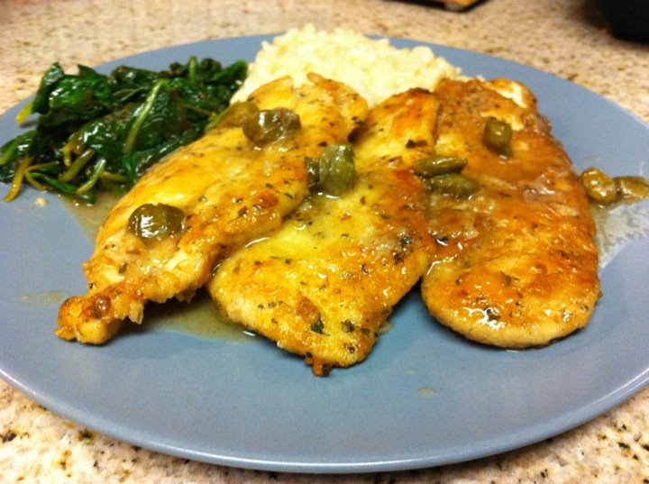 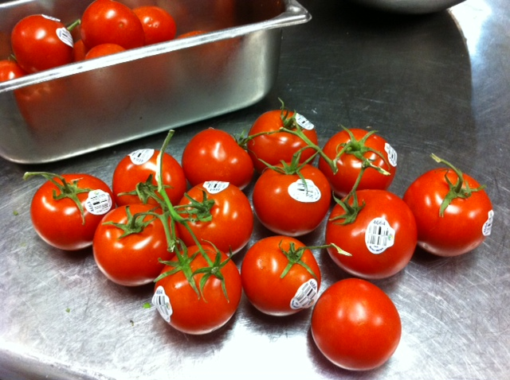

*Food Safety Manager*

*Certification Study Guide*

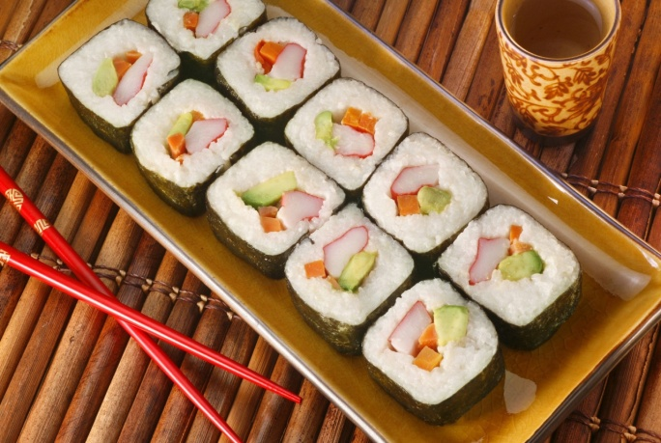 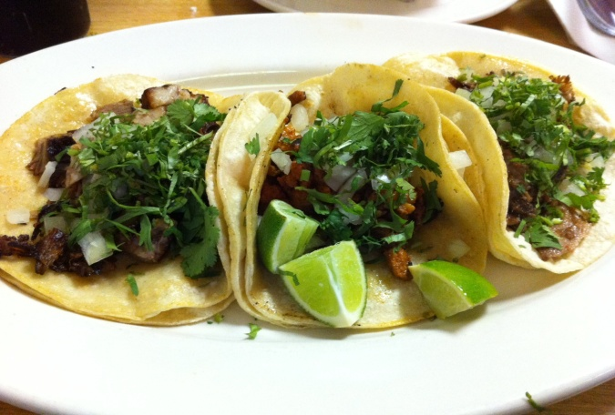

Food for Taught

Agoura Hills, CA 91301

[www.foodfortaught.com](http://www.foodfortaught.com)

856.906.5846

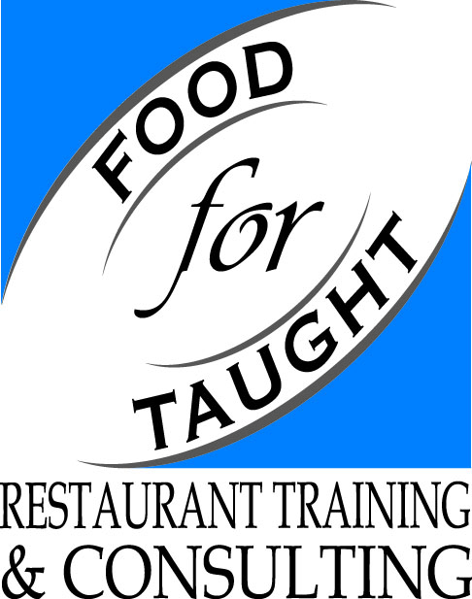

**INTRODUCTION**

Managing a foodservice operation can be a stressful job. The American consumer has high standards for food quality, service, ambience and value. Your day is undoubtedly filled with various tasks aimed at meeting these expectations. However, the first expectation your customer has is often overlooked: Safe food. No one enters a restaurant and expects to become ill from the food they eat.

However, the CDC (Centers for Disease Control and Prevention) estimates that each year:

* 1 in 6 Americans gets sick (48 million cases) from a foodborne illness
* 128,000 people are hospitalized
* 3,000 people die from a foodborne illness

In addition to the above human costs, a foodborne illness outbreak related to your establishment can result in:

* Loss of customers
* Loss of reputation
* Negative media exposure
* Lowered staff morale
* Lawsuits and legal fees
* Staff missing work
* Increased insurance costs
* Staff retraining



Food Safety Education also costs you time and money, but the benefits far outweigh the risks. You have a social obligation to serve your products safely to our community. Our company, Food for Taught, aims to facilitate the training necessary to meet this obligation, while helping you maintain good customer service and profitability.

Table of Contents

**People Affected by Foodborne Illness4**

**How Food Becomes Unsafe4**

**Microorganisms5**

**Temperature Control for Safety Foods6**

**Food Safety Regulation6**

**Viruses7**

**Common Viruses that Cause Foodborne Illness8**

**Bacteria9**

**Common Bacteria that Cause Foodborne Illness10**

**Parasites12**

**Fungi12**

**Biological Toxins13**

**Chemicals14**

**Food Allergies15**

**Personal Hygiene16**

**Thermometers18**

**Purchasing20**

**Receiving20**

**Storing21**

**Preparing22**

**Cooking24**

**Holding25**

**Cooling25**

**Reheating26**

**Serving26**

**Food Safety Management Systems27**

**Facility Design and Maintenance30**

**Cleaning and Sanitizing31**

**Pest Management33**

**Conclusion34**

**Appendices35**

**PEOPLE AFFECTED BY FOODBORNE ILLNESS**

You may be asking yourself, “what exactly is a foodborne illness?”, or “what defines an outbreak?” Basically, a **foodborne illness** is an illness that is carried or transmitted to people by food. An **outbreak** occurs when two or more people experience the same illness after eating the same food. Common symptoms of a foodborne illness include abdominal pain, nausea, vomiting, diarrhea, fever and dehydration. These symptoms can start within one hour or 90 days of consuming contaminated food, depending on the hazard involved and can last for hours or days. Luckily, the average healthy adult has the immune system necessary to fight off most illnesses. However, certain groups of people with weakened immune systems may have more difficulty recovering from any illness, including those transmitted by food. Foodhandlers must take extra precautions when serving people from high-risk populations.

These **high-risk populations** include:

* Elderly people: People’s immune systems weaken with age.
* Infants and preschool age children: Their immune systems have not built up yet.
* People who are seriously ill or take certain medications: Their system is spread thin.

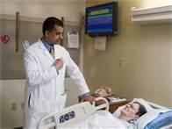

**HOW FOOD BECOMES UNSAFE**

The Centers for Disease Control and Prevention (CDC) has named the five most common risk factors for foodborne illnesses:

1. Purchasing food from unsafe sources
2. Failing to cook food adequately **(time-temperature abuse)**
3. Holding food at incorrect temperatures **(time-temperature abuse)**
4. Using contaminated equipment **(cross-contamination)**
5. Practicing **poor personal hygiene**

Therefore, foodhandlers can limit food safety hazards by combating the three main causes: time-temperature abuse, cross-contamination and poor personal hygiene.

There are three classifications of hazards to food safety:

1. A **Physical Contaminant** is any foreign object that can physically get into the food, such as hair, dirt, metal staples, bandages, broken glass, plastic, etc. Also, a part of the product that is not meant to be eaten, such as bones in a fish fillet or chicken breast can be considered a physical contaminant.
2. A **Chemical Contaminant** is best described as any man-made chemical that contaminates food, such as cleaners, sanitizers, polishes, pesticides and food additives. Toxic metal poisoning occurs when acidic food leaches metal from certain types of cookware and is another example of chemical contamination.
3. A **Biological Contaminant** comes from living things, such as pathogens, which are illness-causing microorganisms. Examples of **pathogens** are bacteria, viruses, parasites and fungi. Some living things also produce toxins, or poisons, which are also a form of biological contamination. Basically, if the contaminant is alive or comes from a living thing, it is a biological contaminant.

Physical and Chemical Contaminants are easier to see and, in some ways, easier to control than Biological Contaminants. For example, by storing chemicals away from food and food-contact surfaces, a foodhandler can limit the possibility of chemical contamination. Similarly, by following proper hygiene practices such as bathing and keeping hair restrained, physical hazards can be monitored. However, with biological contaminants, the threat is invisible to the naked eye and therefore requires more precautions.

**MICROORGANISMS**

Like all living things, microorganisms need certain conditions to grow:

**F**ood – specifically proteins or carbohydrates

**A**cidity – Neutral to slightly acidic pH (4.6 to 7.5)

**T**emperature – Between 41°F to 135°F (**Temperature Danger Zone**)

**T**ime – 4 hours or more within the Temperature Danger Zone

**O**xygen – Some grow best with it, some without

**M**oisture – Water activity of .85 or higher

**TEMPERATURE CONTROL FOR SAFETY (TCS) FOODS**

Certain foods favor the rapid growth of pathogens. They are known as Temperature Control for Safety (TCS) because time and temperature are the two conditions we can control the easiest. Common examples include:

 Milk & Dairy

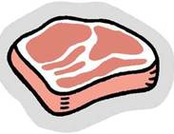Meat

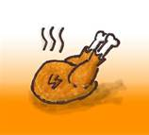 Poultry & Eggs

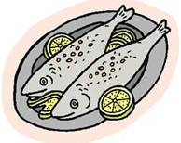Fish

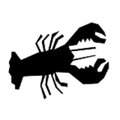Shellfish

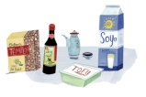Tofu & Soy

Cooked rice, beans & veggies

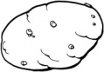 Baked Potatoes

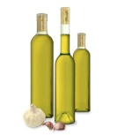Untreated Garlic & Oil mixtures

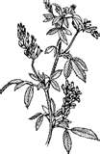 Raw sprouts

Sliced Melons

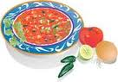Diced Tomatoes

**FOOD SAFETY REGULATION**

The Food and Drug Administration (**FDA**) issues the **FDA Food Code**, which is based on input from the Conference for Food Protection (**CFP**), a collection of experts from the food industry, government, academia and consumer groups. The Food Code outlines the federal government’s recommendations for food safety regulations in the foodservice industry. This is purely a recommendation, not a law. The states must then decide if they want to adopt the Food Code or some portion of it in their own laws.

Health Inspections

Once a state creates its own food safety laws, health inspectors from city, county or state health departments conduct inspections of foodservice operations. Inspections are an important defense for public safety and the reports become public record. All operations serving or selling food receive inspections and are important to ensure critical food safety practices are being followed.

When an inspector arrives at your establishment, make sure to ask for proper identification and the reason for the visit. It may be a routine inspection or a result of a customer complaint. Do not deny entry and always cooperate, by answering questions to the best of your ability. Take notes and keep the relationship professional. Do not offer food, drink or anything else that can be construed as a bribe. Be prepared to provide records of previous inspections, recent purchases, chemical information and training records. Discuss any violations and time frames for correction. If you are unsure about something, make sure to gain clarification. The health inspector can be a great tool for your operation’s food safety training. You will be asked to sign the report and given a copy, which must be kept on file. Make sure to follow up on all deficiencies noted. Revise policies and procedures as necessary.

Your operation can be closed for any of the following reasons:

* Significant lack of refrigeration
* Backup of sewage
* Emergencies such as fire or flood
* Significant pest infestation
* Long interruption of water or electrical service
* Clear evidence of a foodborne-illness outbreak

Self-inspections should be carried out in addition to those conducted by your health department. They can be conducted by your management team or an outside company. Operations that perform self-inspections usually receive higher inspections scores and benefit from safer and better-quality food, as well as a cleaner environment for your team.

**VIRUSES**

Viruses are opportunistic microorganisms that infect the cell of a living thing and take over its functions. The virus then uses the host cell to create new virus cells so it can grow and spread throughout the host. Viruses do not grow in food but use food as a vehicle to find its next victim. Viruses are easily transmitted and can contaminate food, water and food-contact surfaces.

When people get a viral foodborne illness, it is usually from a foodhandler who had the virus. People excrete viruses through their feces, urine and respiratory tract and eating a small amount of a virus can make you sick. Therefore, foodhandlers must wash their hands properly after using the restroom, sneezing, coughing and handling dirty plates and glasses. Otherwise, they run the risk of spreading the virus, especially when handling **RTE** or **ready-to-eat foods** (items that will not be cooked) such as salads, sandwiches, fresh fruit and vegetables. Viruses can spread quickly in closed places like daycare centers, nursing homes, schools and cruise ships. Even after symptoms disappear, these viruses can stay in your stool for two weeks.

**COMMON VIRUSES THAT CAUSE FOODBORNE ILLNESS**

Hepatitis A

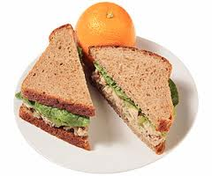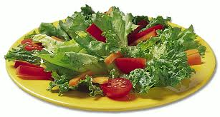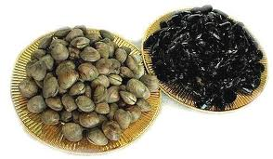

Hepatitis A is a highly contagious virus that attacks the liver. It is most often associated with ready-to-eat food and shellfish from contaminated water. Common symptoms include mild fever, fatigue, nausea and abdominal pain (especially on your right side below your ribs). If you contract Hepatitis A, you may later experience **jaundice**, which is a yellowing of the skin and eyes. Symptoms take a few weeks to materialize and can last anywhere from 2-6 months.

Norovirus



Norovirus is responsible for over 50% of reported foodborne illnesses. Like Hepatitis A, Norovirus is commonly contracted from eating contaminated RTE food and shellfish. A common way to contract and spread Norovirus is touching dirty plates and failing to wash hands properly. In the US, most Norovirus outbreaks occur from November to April. Like Hepatitis A, Norovirus will give you abdominal cramps and nausea but will be accompanied by diarrhea and vomiting instead of fever, fatigue and jaundice. People infected with Norovirus are contagious within a few hours after eating even a tiny amount of the virus.

**BACTERIA**

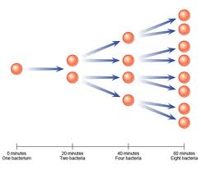**Bacteria** are single-celled microorganisms that are present throughout our world: in soil, water, food, plants, animals and even humans. In fact, bacteria were the first forms of life on Earth, some 4 billion years ago. Most bacteria are harmless to humans because of our powerful immune systems, and some are even beneficial. Some bacteria simply spoil food, but others can cause infectious diseases, such as foodborne illness.

Unlike Viruses and Parasites, Bacteria do not need a host organism to live and multiply, which means they can grow just about anywhere. But with the favorable FAT TOM conditions, bacteria can grow very rapidly, doubling in size every 20 minutes.

As previously mentioned, if we keep food in the Temperature Danger Zone (41°F-135°F) for four hours or more, the bacteria can multiply to quantities large enough to make someone sick. So, if we limit the time food is spent in the Temperature Danger Zone we can reduce the risk.

Toxins

Some bacteria can form **toxins** (poisons) which cause illness, even if the bacteria have been killed. The toxins are created as a waste product of the multiplication process and cannot be destroyed by cooking or freezing. This means that once a food contains a toxin, you’re stuck with it! So, it is important to practice all methods of food safety, even if you are going to cook the food to a high temperature. You must limit the time food spends in the Temperature Danger Zone before and after cooking, as well as, practicing good personal hygiene and preventing cross contamination.

Spores

Certain bacteria can survive freezing and cooking by changing into a different form called **spores**. This defense mechanism can also happen when nutrients are not available. Spores are commonly associated with food grown in soil but can also contaminate other foods exposed to soil or dust. When conditions (FAT TOM) become favorable again, the bacteria revert to their original form and continue growing. This is yet another reason to maintain strict time-temperature control after cooking a product.

**COMMON BACTERIA THAT CAUSE FOODBORNE ILLNESS**

E. coli

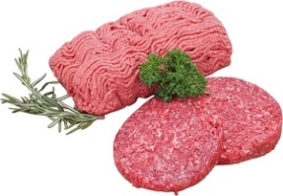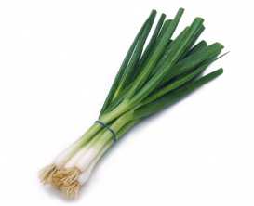

Shiga toxin-producing Escherichia coli 0157:H7 – No wonder we call it E. coli for short! More than likely, you’ve heard about an E. coli outbreak in the news. E. coli is a toxin-mediated infection, which means that it will grow in the intestines of a human and produce a harmful toxin. E. coli is found naturally in the intestines of cattle, goats, sheep and deer and does not usually make animals sick. The E. coli that makes humans sick is most often found in cattle, which can be contaminated during the slaughtering process, so ground beef is a major concern. E. coli can be killed by cooking ground beef to a minimum internal temperature of 155°F for 15 seconds.

Although 90% of E. coli outbreaks come from ground beef, E. coli can also be spread by consuming contaminated produce or not washing hands properly after encountering feces at a petting zoo. Common symptoms include bloody diarrhea and abdominal cramping. Symptoms usually start within 3-4 days of eating contaminated food, but it is possible to become sick in as few as 24 hours, depending on how much of the bacteria have been consumed. About 5-10% of those diagnosed with an E. coli infection develop hemolytic uremic syndrome (**HUS**), resulting in decreased urination, fatigue and possible kidney failure.

Salmonella Typhi



Salmonella Typhi lives only in the bloodstream and intestinal tract of humans. It is commonly linked with ready-to-eat food and beverages. Washing hands and excluding foodhandlers with salmonella typhi are critical prevention measures.

Salmonella (nontyphoidal)

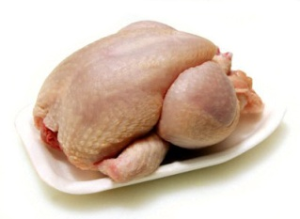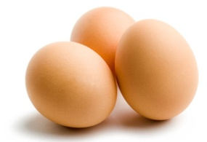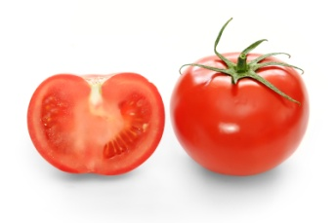

Like E. coli, many farm animals naturally carry Salmonella in their intestines. However, Salmonella is primarily associated with poultry and eggs. It is often found in cross-contaminated produce and sometimes found in unpasteurized dairy products. Common symptoms are diarrhea, vomiting, abdominal cramps and fever. The most important prevention method is to prevent cross-contamination between poultry and RTE foods. It is also important to cook poultry and eggs to their required minimum internal cooking temperatures. The FDA recommends the use of pasteurized eggs, especially when preparing dishes that require little or no cooking, such as hollandaise sauce or when pooling several eggs together. But, if you serve a primarily high-risk population, you must use pasteurized eggs.

Shigella



Found in the feces of humans, Shigella spp. is associated with food that is prepared by hand, such as salads that contain Temperature Control for Safety (TCS) ingredients, such as potato, tuna, shrimp, macaroni and chicken. Shigella is also linked to produce that has contacted contaminated water. Flies also contaminate food by landing on feces before landing on food. Symptoms include bloody diarrhea, abdominal pain and fever. The most important prevention methods are washing hands and controlling flies inside and outside the premises.

THE BIG 6

“THE BIG 6” or as we like to call them, the H Ness monster:

**H**epatitis A **N**orovirus **E**. coli **S**almonella (x2) **S**higella



So, what is so special about these five illnesses? They are all transmitted by feces and even very small traces of them can make a person ill. They can remain in your stool for two weeks after symptoms have disappeared, making them even more dangerous. Even with proper handwashing, it is possible for one of these five pathogens to be spread. If one of your employees is diagnosed with one of The Big 6, they cannot return to work without medical release from a doctor. In addition, you must notify the local regulatory agency to contain a possible outbreak related to your establishment.

**PARASITES**

A **parasite** is an organism that needs another animal to survive. They use a host organism to live within or feed off and cannot grow in food. Eating food contaminated with a parasite will make you sick and they can be also found in contaminated water, especially when the water is used to irrigate produce. The most important prevention method for all parasites is to purchase from approved, reputable suppliers.

**FUNGI**

Mold

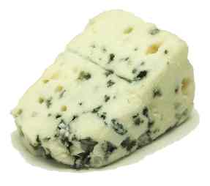

Although it is unpleasant to see, smell, taste and touch, molds do not always cause illness. Molds spoil food and there are some that produce aflatoxins, which can make you sick. Molds grow under almost any condition, but especially in acidic food with little moisture such as jellies, jams and cured salty meats. Refrigerators and freezers may slow the growth of molds, but do not kill them. Cooking will kill molds, but not the toxins that may be present. It is recommended to throw out all moldy food, unless it is a natural part of the product. However, it is permissible to save hard cheeses and salamis by cutting one inch away from all moldy areas.

Yeast

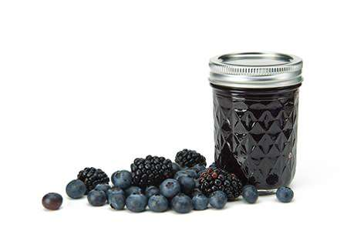

Yeasts also grow well in acidic food with little moisture, such as jams, jellies, syrup and honey. Since yeast spoils food quickly, it is recommended to throw out any food spoiled by yeast. So how can you tell if the food has been spoiled by yeast? It may smell or taste like alcohol, or you may see white or pink discolorations or slime. You may see bubbling as well.

**BIOLOGICAL TOXINS**

Some living things contain or produce poisons for different reasons. Because they are made by a living thing, they are considered a biological hazard. Unfortunately, these toxins have no taste or smell and cannot be destroyed by cooking or freezing. So, the most important prevention method is purchasing from approved, reputable suppliers.

Ciguatera Fish Poisoning

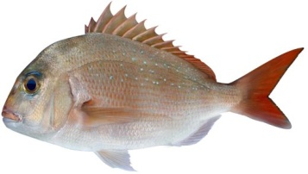

There exist certain marine algae that produce a toxin, named ciguatoxin, which affects the nervous system of the fish that eat it. Humans are affected by eating the predatory reef fish that eat these fish, such as Barracuda, Grouper, Jacks and Snapper. This causes symptoms of nausea, vomiting, tingling in the fingers, lips or toes, joint and muscle pain and reversal of hot and cold sensations for months or years, depending on how much ciguatoxin was consumed.

Scombroid Poisoning

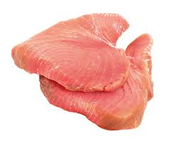

There is a bacteria found on scombroid fish like tuna, bonito, mackerel and mahi mahi, that when given the proper conditions, can grow and produce a toxin called histamine. Histamine causes a reddening of the face and neck, sweating, headache and burning or tingling in the mouth or throat. Diarrhea and vomiting may follow. So, in addition to proper purchasing, it is also important to prevent time-temperature abuse on your watch.

Plant and Mushroom Toxins

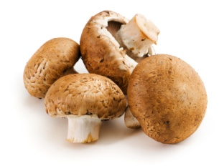

Certain mushrooms and plants can make you sick when they are not purchased from approved reputable suppliers. Poisonous species can be mistaken for edible ones. Also, kidney beans must be fully cooked to keep people safe.

**CHEMICALS**

Foodservice (man-made) Chemicals can contaminate food if they are not used or stored properly. To be safe with chemicals, follow these basic guidelines:

* Store chemicals away from food and food-contact surfaces.
* Always follow the manufacturer’s directions for use
* Be careful if using chemicals during food preparation times
* Keep chemicals in their original containers
* If you must transfer a chemical to a new container, label it with its common name.
* Only use lubricants safe for foodservice use.

Toxic Metal Poisoning

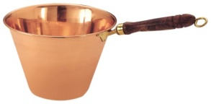

Toxic metal poisoning can occur when an acidic food is prepped with or stored in a container that is not made for foodservice use. Examples include lead in a pewter pitcher, copper in a saucepan and zinc in a galvanized bucket. The acid reacts with the metal in the container, leaching it into the food.

**FOOD ALLERGIES**

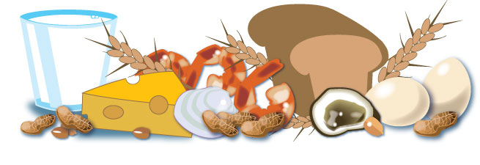

According to the CDC, 2% of adults and 4-8% of children have a food allergy and each year 30,000 Americans end up in the hospital due to an allergic reaction to food. It’s no surprise that we must pay extra attention to food allergies to keep our customers safe. So, what is a food allergy? Basically, it is a body’s negative reaction to a food protein, causing symptoms such as:

* Itching in and around the mouth, face or scalp
* Tightening in the throat or Shortness of breath
* Hives
* Swelling of the face, eyes, hands, or feet
* Abdominal cramps, vomiting, or diarrhea
* Loss of consciousness or death

Common allergens include milk & dairy, eggs, fish, shellfish, wheat, soy, nuts, and sesame. In your establishment, everyone has a part to play to protect customers with food allergies. First, they must take them seriously. Service staff must know how items are prepared and the ingredients that are in them. They must be able to suggest dishes that are allergen free and communicate the allergy to the kitchen team. The kitchen staff must make sure allergens are not transferred from one food or surface to another, which is known as cross-contact. This means the team members preparing the item must wash their hands and change their gloves before preparing the items ordered. All equipment, cookware and utensils must be washed, rinsed and sanitized before use. Fresh oil or water must be used to cook an item for a guest with an allergy. It is a good idea to assign specific equipment for prepping food for customers with allergies.

**PERSONAL HYGIENE**

Poor personal hygiene is the number one cause of foodborne illness. People frequently perform unsanitary actions that contaminate their hands without realizing it. To keep food safe, pay close attention and avoid the following actions (and wash your hands directly after):

* Scratching the scalp
* Running fingers through the hair
* Wiping or touching the nose or ear
* Touching a pimple or infected wound
* Coughing or sneezing into the hand

In addition, you must wash your hands whenever you:

* Use the restroom
* Handle raw meat, poultry and seafood (before and after)
* Eat, drink, smoke or chew gum or tobacco
* Handle chemicals or garbage
* Handle money, dirty dishes or equipment
* Touch your clothing or apron

**Wash your hands, wash your hands, wash your hands:**

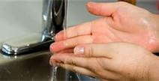 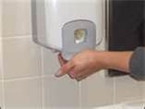 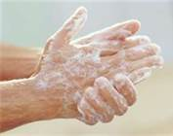

**Wet hands and arms (≥ 100°F) Apply soap Scrub for 10-15 seconds**

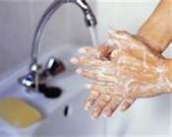 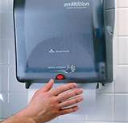 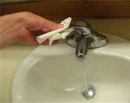

**Rinse thoroughly Dry with paper towel Turn off faucet\***

*Use paper towel to turn off the faucet and open any doors.

**Hand antiseptics** (also known as hand sanitizers) can only be used after handwashing, never in place of handwashing and must comply with FDA standards.

It is important to keep fingernails short and clean and never wear nail polish or false fingernails, as they may contaminate food. Hand wounds must be covered by a bandage and a single-use impermeable glove or finger cot. This keeps the wound from infecting food and the bandage from falling into the food.

Glove Use

Single-use gloves are an effective barrier between food handlers and food but should never be used in place of handwashing. Hands must be washed before putting gloves on and after taking them off to prevent foodborne illness. Gloves should be disposable and available in different sizes with latex alternatives for employees who have an allergy. Never wash and reuse gloves nor roll or blow into them.

To prevent cross-contamination, gloves must be changed:

* As soon as they become dirty or rip
* After an interruption
* After handling raw products and before handling ready-to-eat food
* Before starting a new task
* At least every four hours during continual use

Bare-hand contact can be used only if the dish is cooked to its minimum required internal cooking temperature. Some jurisdictions will allow bare-hand contact with ready-to-eat foods, but only with written policies on employee health and handwashing practices.

Work Attire

Dress codes do more than just make your team look presentable to customers; they also protect your customers! Think head to toe:

* Hair and beard restraints (hats, hairnets, etc.)
* Clean clothing
* Jewelry can not be worn by foodhandlers (except one small finger band)
* Aprons (remove when soiled or leaving food prep areas)
* Clean and close-toed shoes

Do not wear false eyelashes as they can fall into the food. Street clothing and personal items should be stored in designated areas away from food and food contact surfaces.

Saliva

Saliva can contain thousands of pathogens. Therefore, foodhandlers should never spit in the establishment. Also, it is important to eat, drink, chew gum or use tobacco products in designated areas, away from food and food contact surfaces to reduce the spread of saliva.

Reporting Illnesses

Foodhandlers should notify their supervisor of any illnesses before coming to work. The supervisor then must decide if the foodhandler should be restricted from working around food or excluded from the operation entirely.

|  |  |  |
| --- | --- | --- |
| **If the foodhandler has:** | **Then you must:** | **Until:** |
| Sore throat with a fever* | RESTRICT | Symptom-free for 24 hours |
| Uncovered wound or boil | RESTRICT | Symptom-free for 24 hours |
| Persistent sneeze, cough with discharge | RESTRICT | Symptom-free for 24 hours |
| Vomiting and/or Diarrhea | EXCLUDE | Symptom-free for 24 hours |
| Jaundice | EXCLUDE | Medical clearance |
| Been diagnosed with HNESS** | EXCLUDE | Medical and Board of Health clearance |

*\*Must be excluded if serving a high-risk population.*

*\*\*Remember*: ***HNESS*** *=* ***H****epatitis A,* ***N****orovirus,* ***E*** *coli,* ***S****almonella (x2),* ***S****higella. Foodhandlers also must stay home if someone that lives with them has one of these illnesses as they could be* ***carriers*** *and not show symptoms themselves.*

**THERMOMETERS**

As foodservice operators, we are the “middlemen”: we buy food and serve it. What we do to it during that time is called the **flow of food**. To minimize the time that food spends in the Temperature Danger Zone (TDZ) throughout the flow of food, it is important to regularly take temperatures. Several types of thermometers make this possible:

**Bimetallic stemmed thermometers** can monitor temperatures from 0°F to 220°F through its metal stem, making it versatile for foodservice operations. The same thermometer can measure receiving and cooking temperatures. When purchasing one of these, make sure it is accurate within $±$ 2°F and has easy-to-read markings and a calibration nut. It should also have a **dimple**, which is a small notch that shows where the **sensing area** begins. When taking temperatures, you should insert the thermometer past the dimple, so that the reading measures the product, not the area surrounding it. Insert the thermometer in the thickest part of the product and take the temperature of multiple spots. Wait at least 15 seconds for the reading to be steady.

**Thermocouples and Thermistors** measure temperatures through a metal stem and display the results on a digital readout. The sensing area is at the tip, so they don’t have to be inserted as far as bimetallic stemmed thermometers. They come in several sizes and shapes with different probes to fulfill varying needs. **Penetration probes** are effective at measuring the internal temperatures of thin foods like burger patties and fish fillets. **Immersion probes** are good for liquids such as frying oil, stocks and sauces. **Surface probes** are useful to check the temperatures of flattops and grills. **Air probes** can give you the temperature of an oven, cooler or freezer.

**Infrared Thermometers** (or laser thermometers) are quick and easy to use, but only measure the surface temperature of a product or piece of equipment. They are not useful to measure air or internal temperatures but reduce the risk of cross-contamination. When using one of these, you must be careful to remove any barriers, such as plastic wrap. Also, you should take a reading as close to the product as possible and follow the manufacturer’s directions.

Glass thermometers should NEVER be used in a foodservice operation because they can break and contaminate food. Thermometers should be cleaned, rinsed and sanitized between uses to prevent cross-contamination. There are also other tools available, such as the **time-temperature indicator**, or TTI, which is a tag that is attached to packaging and shows an irreversible color change if food is time-temperature abused. Another tool is the **maximum registering thermometer** or **maximum registering tape** which indicate the highest temperature reached by the product.

Calibrating Thermometers

If thermometers are dropped or go through extreme temperature change, they may lose their accuracy. It is recommended to adjust the calibration of a thermometer before each shift as well. To adjust, or **calibrate** a thermometer, you can use one of two methods:

**Ice Point Method Boiling Point Method**

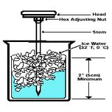 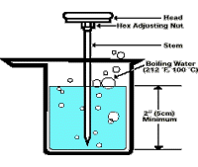

1. Fill a container with either ice water or boiling water.
2. Insert the thermometer and wait 30 seconds for the reading to steady.
3. Hold the calibration nut and rotate the head of the thermometer until it reads 32°F or 212°F, depending on the method you are using. *

*For thermocouples and Thermistors, follow the manufacturer’s directions.

Thermometers that cannot be calibrated should be replaced whenever they lose their accuracy.

**PURCHASING**

If food arrives to your establishment contaminated, you can not make it safer. Therefore, how and from whom you purchase is vital to your success. You should only purchase food from approved, reputable suppliers. This means the supplier has been inspected and meets all local, state and federal laws. You should develop a relationship with your supplier and review their inspection reports. Arrange deliveries to arrive individually and at times when you inspect them properly without interruption. Never forget that you are your suppliers’ customer. Demand the same quality in product and service that your customers expect from you.

**RECEIVING**

To keep food safe as it enters your restaurant, you must make sure you have enough trained staff to receive, inspect and store it. Any receivers should be authorized to accept, reject and sign for deliveries. It is a good idea to keep your purchase orders in the receiving area, along with necessary tools such as a thermometer, utility knife, gloves and sanitizer. If you must reject an item, tell the delivery person exactly why you are rejecting it and make sure to get a signed credit or adjustment. Log the incident and follow up as necessary.

* Receive cold food at 41°F or below and hot food at 135°F or higher.
* Milk must be received at 45°F or below.
* Frozen food should be solid without ice crystals (evidence of thawing and refreezing).
* Packaging should be clean and intact, with no holes or tears and no signs of prior wetness or pest damage. Check for expiration dates on packaged items as well.
* Reject meat, poultry and fish that are slimy, sticky, dry or have an abnormal color or odor. A mild seaweed smell for fish and shellfish is acceptable. The flesh should be firm to touch. Look for the USDA inspection stamps.
* Eggs should be clean and unbroken with an air temperature of 45°F or below.
* Live shellfish must have shellstock identification tags, which need to be kept on file for 90 days past the date the last shellfish was sold or served. Do not accept shellfish that are muddy, broken or dead (don’t close when tapped). Must be 45°F or below.
* Sushi-grade fish should be delivered with records showing the fish was frozen correctly so that it can be consumed raw or partially cooked. Keep documents for 90 days.
* Farm-raised fish must have documentation stating the fish was raised to FDA standards. Keep documents for 90 days.
* Aseptically sealed ultra-high temperature (**UHT**) pasteurized dairy creamers can be received and stored at room temperature.
* Recalls require special attention. Be sure to identify the recalled product, remove it from your inventory and label it so it does not end up back in inventory. Inform staff not to use the product and refer to the vendor’s notification or recall notice for the next steps you should take.

**STORING**

When putting items away, it is important to follow some guidelines. All TCS, ready-to-eat food prepped in-house, must be labeled with the name of the food and the date by which it must be sold, eaten or thrown out. It is a good idea to include other information, such as who prepped the item also. After seven days, the food must be thrown out to prevent Listeria monocytogenes from growing to unsafe levels. To make sure food is not stored for too long, you should always rotate your food using the FIFO (first in, first out) method. This is done by storing items with later use-by or expiration dates behind products with earlier ones and using the products in front first. Any food that passes its manufacturer’s use-by or expiration date should be thrown out immediately to reduce risk.

Remember to keep TCS foods at the temperatures at which they were received, below 41°F or above 135°F. Frozen items should be stored at a temperature that keeps them frozen. Dry storage areas should be kept between 50°F and 70°F. Check these temperatures regularly and record them in a log.

When storing food, use only containers that are intended to store food and place them in specific areas, away from chemicals and cleaning supplies. All food must be covered and stored at least 6 inches off the ground, away from walls to prevent pest infestation. Keep all storage areas clean, dry and well-ventilated. To ensure proper airflow, do not line shelving or overload storage areas. Schedule regular maintenance of your storage areas and defrost freezers periodically to allow them to operate more efficiently.

Preventing cross-contamination in storage

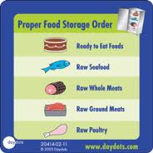In refrigeration, raw meat, poultry and fish must be stored separately from RTE food to reduce cross-contamination. If this is not possible, store food in this top to bottom order: RTE food, Seafood, Whole cuts of meat, Ground cuts of meat and fish, whole and ground poultry. This is based on the minimum internal cooking temperatures. If seafood drips on the whole cuts of meat, the juices will still be cooked to a temperature high enough to kill the pathogens. But, if juices from the meat drip on the fish, they may not get cooked to a high enough temperature. Keeping food covered also reduces the risk of cross-contamination.

**PREPARING**

When preparing food, it is important to minimize the risk of time-temperature abuse by only removing the amount of product you can prepare in a short period of time and cooking prepped product or returning it to the cooler as quickly as possible.

Thawing

Because freezing does not kill pathogens, it is important to thaw food properly. There are 4 correct ways to do this:

* In refrigeration at 41°F or lower
* Under running potable water < 70°F
* In a microwave if cooked immediately
* As part of the cooking process

Produce

Fruit and vegetables should not touch surfaces that have been exposed to raw meats, poultry or fish. Produce must be washed thoroughly under running water that is a little warmer than the produce. Be sure to pull leafy greens apart and rinse thoroughly. When soaking or storing produce in standing water, never mix different items or multiple batches of the same item. Refrigerate and hold cut tomatoes, melons and leafy greens at 41°F or lower. Do not serve raw seed sprouts if you serve a primarily high-risk population.

Batter and Breading

Prepare batter and breading in small batches and throw out unused products after using a batch or the end of a shift. Wash, rinse and sanitize your batter and breading containers between uses to prevent cross-contamination. Use different batter and breading for different items to reduce cross-contamination and to protect people with allergies.

Eggs

**Pooled** eggs are eggs that are cracked open and combined in a container. They must be cooked immediately or stored at 41°F or lower to prevent time-temperature abuse. You must wash, rinse and sanitize containers between uses to prevent cross-contamination.

Consider using pasteurized shell eggs or egg products for products that require little to no cooking, such as hollandaise, mousse and Caesar dressing. If you serve a high-risk population, you must use pasteurized eggs for pooled eggs or recipes that require little to no cooking.

Salads containing TCS foods

Leftover TCS foods (pasta, potatoes, chicken, egg, tuna, etc.) must be handled properly before making salads from them. They must be cooked, held and cooled properly. The leftover ingredients are only good for 7 days from the time they were initially prepared. So, a potato salad must be thrown out 7 days after the potatoes were cooked, not after the salad was made. It is important to date-mark these items with the earliest use-by date for the products used.

Ice

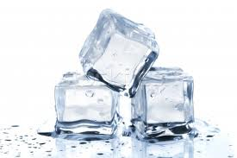Yes, ice is a food and can make people sick if not handled properly. Make ice from water that is safe to drink. Do not use ice as an ingredient if it is used for another purpose, such as cooling or keeping food cold. Never carry ice in containers that have come into contact with raw meat, seafood, poultry or chemicals. Use designated, clean, sanitized scoops that are stored properly between uses. Never use glassware to scoop ice as it may chip off and become a physical hazard.

Variances

A **variance** is a waiver document to a preparation requirement, issued by a regulatory authority. This may require a written HACCP plan, which accounts for any food safety risks throughout the flow of food. Certain practices that require a variance include:

* Smoking or curing food to preserve it
* Using food additives
* Custom-processing animals for personal use
* Packaging food using a **ROP** (reduced oxygen packaging) method, such as sous-vide or **MAP** (modified atmosphere packaging)
* Sprouting beans or seeds
* Offering live, molluscan shellfish from a display tank
* Packaging unpasteurized juice on-site for sale later

**COOKING**

Although cooking reduces pathogens, it does not destroy spores or toxins. Therefore, it is important to handle food properly before and after the cooking process to ensure serving the safest possible product. The required minimum internal cooking temperature is different for each type of food and must be held for at least 15 seconds. The one exception is for roasts, which must hold the temperature for 4 minutes due to the thickness of the product. When checking temperatures, you should insert the thermometer in the thickest part (usually the center) of the product and wait for the reading to steady.

Minimum Internal Cooking Temperatures

|  |  |  |  |
| --- | --- | --- | --- |
| **165** | **155 (17 sec)** | **145 (15 sec)** | **135** |
| Poultry  Stuffed meats  Microwave**  Reheats for HH* | Eggs for HH*  Injected, vacuumed meat  Cubed, ground meat  Pounded, tenderized meat  Ratites | Eggs served immed.  Steaks  Chops  Fish  Roasts (4 minutes) | Grains/Legumes for HH*  Fruit/Veggies for HH* |

*HH = Hot Holding

**Due to the uneven cooking process of a microwave, you need to cover and rotate the product. Let it stand for two minutes and check the temperature in at least two places.

If your menu includes TCS items that are raw or undercooked, you must have a disclosure on the menu, stating that the item is raw or undercooked. You must also advise customers of the risk of foodborne illness through brochures, table tents, signage or other written materials.

**HOLDING**

It should be apparent by now that you must hold cold food below 41°F and hot food above 135°F, but there are a few other guidelines that will keep food safe at your establishment. Check temperatures by inserting a thermometer into the product. Do not rely on the temperature gauge of a holding unit. Check the temperature every four hours and throw out any product that is not at the correct temperature. As an alternative, you can check the temperature every two hours, so you have time for corrective action.

Never use hot-holding equipment to reheat or cook food unless it is built to do so. Reheat or cook the items correctly and transfer them to the hot-holding unit. Set a predetermined amount of time to discard a product.

It is acceptable to hold food without temperature control such as at an off-site catering event. However, you must label the product with its name, the time it was removed from proper temperature control and the time by which it must be sold, consumed or discarded. If this is done correctly, hot food can be held without temperature control for 4 hours. Cold food can be held for 6 hours, so long as the food never reaches 70°F.

**COOLING**

As you are aware, pathogens grow well between the TDZ temperatures of 41°F - 135°F. However, food scientists have found that pathogens grow extremely rapidly between 70°F and 125°F. Food must pass through this range as quickly as possible to limit growth. *(This is also why dry storage rooms must be kept below 70°F.)* You should start the cooling process by reducing the size. You can cut large items into smaller pieces and divide large pots into shallow pans. Increasing the surface area will allow the product to cool more quickly. Stainless steel pans are recommended, as the metal will transfer heat away from the product faster than plastic.

Two-stage cooling (2+4=6)

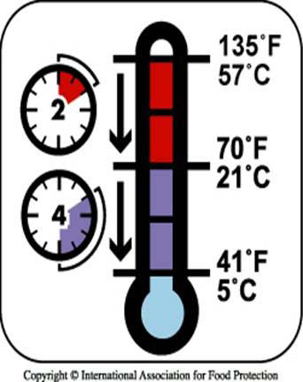When cooling food, you must bring the temperature from 135°F to 70°F within the first 2 hours. Certain equipment (if available to you), such as blast and tumble chillers, are extremely effective. But for most operations, using an ice-water bath and/or ice paddle will achieve this fast enough. You can also add ice to stocks, soups and other recipes, where water is an ingredient. At 70°F, the product is at room temperature and can be placed in refrigeration. Please note: Placing hot product in a cooler is dangerous because it can warm the interior of the unit, bringing other products into the temperature danger zone. If you are unable to get the product to 70°F within 2 hours, it must be reheated and cooled again. Once it is below 70°F, you have 4 hours to get the product below 41°F.

**REHEATING**

Food reheated for immediate service can be served at any temperature, if it was cooked and cooled correctly. However, TCS foods that will be hot held, must be reheated to 165°F for 15 seconds within 2 hours. If not, it must be discarded or cooled again and reheated. There are alternate time and temperature requirements for roasts, but you should check with your local regulatory authority for specifics.

**SERVING**

As you know, the biggest threat to serving food safely is contamination by hands. It is important to use gloves, deli sheets and tongs to minimize bare-hand contact with RTE food. Use utensils that are specific for each food item to reduce the risk of cross-contamination. Store them in the product with the handle extended above the rim of the container or on a clean, sanitized surface. Utensils must be washed, rinsed and sanitized every four hours.

Service team members must never touch the food-contact surfaces of glassware and china. Be careful how you transport glassware and china to reduce breakage. Hold flatware by the handle and store it in a way so a foodhandler can grab it by the handle. Preset tableware must be removed when Guests are seated or washed, rinsed and sanitized between Guests.

Extra preset tableware must be removed when Guests are seated or must be cleaned and sanitized if they remain on the table.

It is not permissible to reserve any food items, bread, garnishes or condiments returned by a customer to another customer. Only unopened, prepackaged food can be reserved, such as wrapped crackers and ketchup packets.

**Self-service areas** - It is important to label all items, including dressings. Sneeze guards should be installed so that they are 14” above the food and extend 7” beyond the food. Do not allow customers to refill dirty plates or utensils to the buffet. Post signage and/or designate a team member to facilitate this etiquette. Bulk food must be labeled with manufacturer information.

**Vending machines** – Food should be handled with the same care as food served directly to customers. Shelf life should be checked daily and expired products discarded. TCS foods must be kept at the appropriate temperature and dispensed in their original containers. Fruit with edible peels should be washed and wrapped prior to being placed in the vending machine.

**Off-site events** - Make sure you use clean delivery vehicles and insulated food-grade containers. As always, label everything and check temperatures regularly. Store items separately and ensure you have the means to wash hands and store garbage away from food.

**Consumer Advisories** – The FDA advises against serving raw or undercooked meat, poultry, seafood, and eggs on a children’s menu. Operations that serve primarily high-risk populations must never serve raw seed sprouts, raw or undercooked eggs, meat, or seafood.

**Food packaged on-site for retail sale** – Labels must include the common name of the food, quantity of the food, a list of ingredients by weight, list of artificial colors, flavors, and preservatives, name and place of the manufacturer, packer, or distributor and all allergens.

**Refilling take-home containers** – These can be refilled only if they were designed for reuse, provided by the operation to the guest, cleaned and sanitized properly.

**FOOD SAFETY MANAGEMENT SYSTEMS**

Person in Charge

Every foodservice operation must have a person-in-charge (PIC) for each shift. The PIC can be a manager, supervisor, or employee with a food safety manager certification. The PIC must know how to prevent foodborne illness, how to follow the HAACP principles (below), and what the regulatory agency requires. Basically, they must ensure that food safety is being implemented and followed in the operation.

So now you know the basics of food safety management: who gets sick, how and why they get sick and what you need to do to prevent it at your establishment. Now, it’s time to put it all together! A **food safety management system** is a group of procedures and practices that actively control the risks and hazards throughout the flow of food. For a food safety management system to be effective, the following programs must exist:

* Personal hygiene program
* Supplier selection and specification program
* Sanitation and pest-control program
* Facility design and maintenance program
* Food safety training program

Active Managerial Control

**Active managerial control** focuses on the CDC’s five most common risk factors: purchasing, cross-contamination, cooking, holding and personal hygiene (*see: How Food Becomes Unsafe*). There are four main steps to active managerial control:

1. Identify Risks throughout the flow of food in your operation. Identify issues that could impact food safety.
2. Monitor to counteract these risks.
3. Corrective Action – take appropriate actions to fix any deficiencies
4. Management Oversight - verify all procedures and policies are being followed closely.
5. Training – train and retrain employees as needed.
6. Re-evaluation. Use feedback from internal sources, such as temperature logs, and external sources, such as health-inspection reports to ensure it’s working.

HACCP

**Hazard Analysis Critical Control Point** is based on the philosophy that if you can identify hazards throughout a specific product’s flow of food throughout your establishment, the hazards can be prevented, eliminated or reduced to safe levels. An effective HACCP plan is written and specific to each facility’s menu, customers, equipment and processes. A HACCP plan that works for one establishment may not work for another. As previously mentioned, a HACCP plan may be required for any processes that require a variance (*see: Preparing*).

Crisis Management

In the event of a food-related crisis, your response can make or break your reputation and liability. Examples of food crises include foodborne illness, product recalls, water or power interruption, sewage backup and flood. To deal with a crisis effectively, you should create a written crisis management plan to cover preparation, response and recovery. After creating the plan, you should test it and revise it as necessary.

A crisis management team, including representatives from several departments (or just key management in small operations), should meet regularly to prepare for crises. They should review health inspection reports, create action plans, assign tasks and follow up on deficiencies. Every operation should have incident forms and emergency contact lists readily available.

Emergencies that affect the operation can be categorized as:

* Imminent health hazards – significant threat or danger to health
* Possible imminent health hazards – electrical outages, refrigeration breakdowns, fires, floods, sewage backups, threats to the potable water supply, etc.

How you respond to these hazards is critical. If there is a significant risk to the safety or security of the food, you must stop service and notify the regulatory authority. Be sure to throw out spoiled food, contaminated food, and food with improper packaging.

Handling Foodborne Illness Complaints

* Take the complaint seriously.
* Do not admit liability but show concern.
* Fully complete the incident form.
* Find out if anyone else became sick.
* Most Guests just want to be heard.
* Don’t forget to thank the Guest.

Evaluate the complaint to determine if there are similar complaints. If there are:

* Identify the common food items and contact the local health department.
* Obtain samples and isolate the food.
* Follow your crisis management plan and let spokesperson handle all communication.

Deliberate Contamination of Food

Unfortunately, there are people who wish to deliberately contaminate food and make people sick. This may include terrorists, activists, former employees, vendors and competitors. As an operator, you must be **ALERT**:

* + **A**ssure – received products are safe
  + **L**ook – monitor security of products in facility
  + **E**mployees – know who is in the facility
  + **R**eports – keep food defense records accessible
  + **T**hreat – identify who to contact when necessary

**FACILITY DESIGN AND MAINTENANCE**

The design of a facility has to be created so that it keeps food safe. By creating good workflow, you can reduce the time food spends in the temperature danger zone. For example, storage areas should be near the receiving area. Cross-contamination can be reduced by a design that places one piece of equipment where it will not splash or spill anything on another piece of equipment. A good layout will also make equipment more accessible for cleaning. Design plans must be reviewed by the local zoning board and board of health to be compliant with all laws.

Flooring and Equipment

Flooring must be smooth, nonabsorbent, durable and easy to clean. **Coving** is a curved, sealed edge that connects a floor and a wall. This prevents wall deterioration and pest infestation, while making the edges easier to clean.

All equipment for use in a foodservice establishment must have either a NSF or UL EPH or UL classified marks. This means they have been evaluated, tested and certified. Floor-mounted equipment must be at least 6” off the ground or sealed to a masonry base. Tabletop equipment must be at least 4” off the table, sealed to the counter or tiltable for cleaning. Regular maintenance is required for all equipment.

Plumbing

Handwashing stations must be in areas that promote proper handwashing. They must contain:

* Hot and Cold running water
* Soap
* Means to Dry hands (paper towels or warm air hand dryer)
* Garbage container
* Signage telling employees to wash their hands before returning to work

It is important to only use a specific type of sink for its designed purpose (handwashing vs. food preparation vs. dishwashing). Potable (drinkable) water must come from an approved source. If your water comes from a private source, it must be checked at least once a year. Plumbing should only be installed or maintained by a licensed plumber, or you run the risk of contaminating your water supply. A **cross-connection** is a physical link between safe and dirty water. An example of this would be a hose connected from a faucet filling up a mop bucket. If the pressure drops, backflow may occur. **Back siphonage** is a vacuum created in the plumbing system that sucks contaminants into the water supply. **Backflow** is the reverse flow of contaminants into a clean water supply. To prevent this, you can install a vacuum breaker. However, an air gap is the best solution as water cannot defy gravity and jump into a clean water supply. An **air gap** is a space of air between the faucet and the flood rim of a sink or between a sink drain and a floor drain.

You must also maintain grease traps so that you do not have a backup of dirty water. Check pipes regularly to make sure there are no leaks that can drip onto food or food contact surfaces. Backup of sewage or wastewater requires closing, correction and thorough cleaning.

Lighting

Good lighting promotes a safe and clean work environment for your team. Always use shatter-resistant light bulbs or protective covers to keep broken glass from falling into food. Food preparation areas require the most light (50 foot-candles), so that team members can make sure to follow critical food safety practices. Walk-ins, storage areas and dining rooms require the least amount of light (10 foot-candles). Every other area requires 20 foot-candles.

Ventilation

If ventilation is inadequate, grease can build up on your walls. Therefore, you must ensure that hood filters are tight fitting and easy to clean. You should have a professional clean your ventilation system periodically as well.

Garbage

Garbage must be removed as soon as possible to limit odors, pests and the risk of contamination. Indoor containers must be leak-proof, waterproof and pest proof. Outdoor containers should be kept on smooth, non-absorbent surfaces with tight lids and drain plugs in place, as far away from your entrance doors as possible. All garbage containers must be regularly cleaned inside and out.

**CLEANING AND SANITIZING**

**Cleaning** is the process of removing dirt and debris from the surface. **Sanitizing** is reducing pathogens on the surface to safe levels. All food contact surfaces need to be cleaned, rinsed and sanitized: after use, before starting to work with a new type of food, any time a foodhandler is interrupted during a task and every 4 hours during continual use. Cleaners must be stable, non-corrosive and safe to use. Always follow the manufacturers’ directions! Use cleaners for their intended use and never combine them. Cleaners and sanitizers must be provided and available to employees during all hours of operation.

There are two ways to sanitize. **Heat sanitizing** is soaking an item in water of at least 171°F for at least 30 seconds. **Chemical sanitizing** is rinsing, swabbing or spraying an item with chlorine, iodine or quaternary ammonium compounds (quats). Sanitizer effectiveness is determined by concentration, temperature, contact time, water hardness and pH. With chemicals, always defer to the manufacturer’s instructions.

Machine Dishwashing

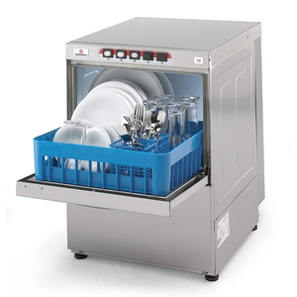There are also two types of dishwashing machines: high-temperature and chemical-sanitizing. For high-temperature machines, the final sanitizing rinse must be at least 180°F. For stationary rack, single-temperature machines, it must be at least 165°F. These machines must have a built-in thermometer gauge. For chemical machines, follow the manufacturer’s directions.

Keep dishwashing machines clean, clearing spray nozzles and using a delimer when necessary. Prepare items for the machine by scraping, rinsing and soaking. Do not overload racks and be sure to inspect items when the racks come out of the machine. Air-dry all items and monitor the temperature and pressure of the machine.

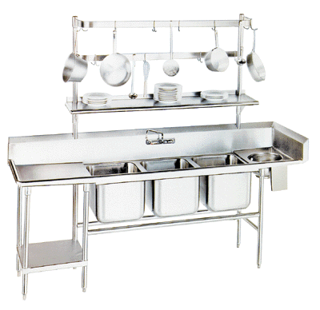Manual Dishwashing

Three-compartment sinks must be washed, rinsed and sanitized before use. Follow these steps when using a three-compartment sink:

1. Rinse, scrape or soak items before washing.
2. Wash items in the first sink (at least 110°F)
3. Rinse items in the second sink.
4. Sanitize in the third sink. (Do not rinse again!)
5. Air-dry items upside down, so they drain properly.

Cleaning the Premises

Even non-food contact surfaces must be cleaned regularly to prevent the accumulation of dust, dirt and food residue. Never use cleaning chemicals, tools or towels for any purpose other than cleaning. Store all cleaning tools and supplies so that they can air dry in a storage area away from food and food prep areas. Only foodservice chemicals should be used and must be stored, labeled and disposed of properly.

**Material Safety Data Sheets** (MSDS) must be kept accessible for all chemicals used in your establishment. MSDS are required by the Occupational Safety and Health Administration (OSHA) and cover all pertinent information for a chemical, such as safe use and handling, hazards, precautions, personal protective equipment (PPE), first aid information and the manufacturer’s contact information.

A **master cleaning schedule** is a cleaning program that lists what should be cleaned, who should clean it, when and how it should be cleaned. Each establishment must have written procedures for cleaning up vomit and diarrhea to minimize contamination and reduce exposure to food people, and food contact surfaces.

**PEST MANAGEMENT**

Pests are more than unsightly to customers: they damage food and spread diseases, such as foodborne illnesses. An integrated pest management system starts with prevention. If you already see them in your establishment, you may have an infestation.

Deny access

You must take a proactive approach to prevent pests from entering your establishment. You should use approved, reputable suppliers and check deliveries for signs of pests. Screen all windows and vents with at least 16 mesh per square inch screening to prevent flies from entering the premises. Installing self-closing devices, air curtains and door sweeps will also deny pests’ access. Pipes act as highways for mice, rats and roaches. Therefore, fill holes around pipes, seal any cracks in floors and walls, cover floor drains and install screens over ventilation pipes and ductwork.

Deny food, water and shelter

Pests like damp, dark and dirty places, so cleaning your establishment properly is a good defense. Throw garbage out quickly and keep both garbage and recyclables in clean, pest-proof containers. Store all food and supplies quickly (at least 6” off the ground) and rotate product so pests can not settle and breed. Clean up spills quickly, keep cleaning tools and supplies clean and dry, and minimize standing water.

Working with a licensed PCO

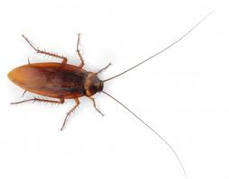A licensed Pest Control Operator (PCO) is your best defense against pests who have entered your establishment. They will help you with pest identification, applying pesticides and preventing future incidents.

Cockroaches have a strong, oily odor, capsule-shaped egg cases and droppings that look like black pepper. Rodents may leave signs of gnaw marks, tracks and droppings that are either shiny and black (fresh) or gray (old). They like soft materials for nesting and usually nest in quiet places near food and water, such as holes next to the building.

Pesticides should only be applied by a licensed PCO, as they know the best and safest pesticides to use in each situation. This will also make sure pests do not develop resistance or immunity to pesticides. Not all pesticides are approved for use in a foodservice establishment and can be harmful to employees and customers. Before pesticides are applied, you must prepare by removing all food and movable equipment. Immovable equipment must be covered, then washed, rinsed and sanitized after the pesticides have been applied. Pesticides must be kept in their original containers in a secure location, away from food and food-contact surfaces. Check local regulations before discarding pesticides or containers.

**CONCLUSION?**

Now that you know how to keep food safe, the most critical step can begin: training your team. Your first objective is to find out what your team knows about food safety. You can do this by observing them as they work, testing them and surveying them. Look over previous health inspection reports to find patterns. This may indicate a **training gap,** which is a gap between what your team knows and what they need to know.

There are many ways to achieve training, and they all take preparation. On-the-job training (OJT) teaches skills that require thinking and doing, such as handwashing. This can be done individually or in small groups. Classroom training will result in a more homogenized outcome and activities are recommended to reinforce the information. Examples include information search, guided discussion, demonstration, role-play, games and watching training videos. When conducting a demonstration, use the tell-show-tell-show method. Tell them and show them, then have them tell you and show you. Technology-based training is another approach.

All team members need critical food safety knowledge, such as proper handwashing and other hygienic practices, cleaning and sanitizing procedures and safe chemical handling. You should also provide job specific information about safe food preparation and serving. Training is never done, so retrain periodically, keep records and reward good behavior!

**TEMPERATURE REVIEW**



**220°F** – Top of temperature range for bimetallic stemmed thermometer

**212°F** – Boiling point (for calibrating thermometers)

**180°F** – Final rinse for heat-sanitizing dish machines

**171°F** – 3rd sink for heat-sanitizing by immersion (manual dishwashing)

**165°F** – Cooking poultry, stuffed meats and fish, microwaved items, wild game; reheating for HH; final heat-sanitizing rinse (stationary single-rack machine)

**155°F** – Cooking injected meats, ground meats, eggs for HH

**145°F** – Cooking steaks, chops, roasts, fish, eggs for immediate service

**135°F** – TOP OF THE TDZ; minimum for HH; Cooking veggies and RTE for HH

**110°F** – 1st sink for washing (manual dishwashing)

**100°F** – Minimum for handwashing

**70°F** – room temperature; maximum for dry storage; 1st step of 2-stage cooling

**50°F** – Minimum for dry storage

**45°F** – Minimum temperature for receiving/storing milk, shellfish & shell eggs

**41°F** – BOTTOM OF THE TDZ; maximum for cold holding; maximum for receiving/storing TCS foods; 2nd step of 2-stage cooling

**32°F** – Ice point (for calibrating thermometers)

**0°F** – Bottom of temperature range for bimetallic stemmed thermometers

**GLOSSARY OF TERMS**

**Aflatoxin** – poison from certain molds found in grains and cereals

**Air curtain –** a machine that produces an air stream across a doorway to deny access to flies

**Air gap** – the space between a sink drain and a floor drain or a faucet and the sink’s flood rim

**Anaerobic** – living in the absence of oxygen

**Antiseptic** – a sterilizing sanitizer; destroys living germs of disease

**Aseptic** – free from the living germs of disease

**Backflow** – the reverse flow of contaminants into a clean water supply

**Ciguatera** – a tropical disease caused by ingesting toxic marine algae

**Coving** – curved edge connecting walls and flooring

**Cross-connection** – a physical link between dirty and clean water supplies

**Dimple** – notch on a thermometer, indicating the top of the sensing area

**Foot-candle** – a unit of illumination, measured by one candle at a distance of one foot

**Jaundice** – a yellow discoloration of the skin and eyes, caused by excess bile in the blood

**Microorganism** – a living thing so small it can only be seen through a microscope

**Outbreak** – when two or more people have the same symptoms after eating the same food

**Pasteurize** – to expose a food to an elevated temperature for a sufficient period of time

**Pathogen** – an illness-causing microorganism

**Pooled** – when more than one egg is cracked into a bowl

**Scombroid** – resembling or related to the mackerel family of fish

**Spore** – a protective bacterial form, which allows survival until growth conditions are favorable

**Sushi-grade** – fish that has been frozen to extreme time and temperature requirements

**Toxin** – any poison produced by a living organism

**Vacuum breaker** – device designed to prevent backflow of dirty water into clean water

**ACRONYMS**

**CDC** – Center for Disease Control (studies causes and effects of illnesses)

**CFP** – Conference of Food Protection (meets and advises the FDA on food safety regulations)

**FAT TOM** – Food, Acidity, Time, Temperature, Oxygen and Moisture

**FDA** – Food and Drug Administration (writes the federal guidelines for food safety)

**FIFO** – First in, first out (product rotation)

**HACCP** – Hazard Analysis Critical Control Point (very specific food safety management system)

**HNESS** – Hepatitis, Norovirus, E coli, Salmonella, Shigella (The Big 5)

**HUS** – Hemolytic uremic syndrome (complication of E. coli infection)

**IPM** – Integrated Pest Management

**MAP** – Modified Atmosphere Packaging

**MSDS** – Material Safety Data Sheets (lists and describes chemicals used in the workplace)

**NSF/UL** – acceptable marks for foodservice equipment

**OSHA** – Occupational Safety and Health Administration (enforces laws to protect employees’ safety and health)

**PCO** – Pest Control Operator

**PHF** – Potentially Hazardous Food

**PIC** – Person in Charge

**ROP** – Reduced Oxygen Packaging

**RTE** – Ready-to-eat foods (do not require further cooking before consumption)

**TCS** – Temperature Control for Safety foods

**TDZ** – Temperature Danger Zone (41°F - 135°F)

**UHT** – Ultra-high temperature pasteurizing (creamers)

**USDA** – U.S. Department of Agriculture (inspects and grades meat, poultry and eggs)

**PRACTICE EXAM**

1. At what internal temperature should raw meat, poultry, and seafood be stored?
   1. 41°F (5°C) or lower
   2. 45°F (7°C) or lower
   3. 51°F (10°C) or lower
   4. 55°F (13°C) or lower
2. Where should foodhandlers eat and drink while on break?
   1. In the chemical closet
   2. In dry storage
   3. In designated areas
   4. In food preparation areas
3. Wheat, milk and shrimp are dangerous for people with what condition?
   1. Food allergies
   2. Cross-connection
   3. Poor personal hygiene
   4. Toxic-metal poisoning
4. When should you use a hand antiseptic?
   1. Before washing hands
   2. During hand washing
   3. After hand washing
   4. In place of hand washing
5. What must you do before applying pesticides in a foodservice establishment?
   1. Cool and reheat all TCS foods to the required temperature
   2. Make sure employees are on-site
   3. Wash, rinse and sanitize all food contact surfaces
   4. Wrap all food and cover all immovable equipment
6. Which of the following is the correct storage rotation method?
   1. FDA
   2. FIFO
   3. NSF
   4. CFP
7. A foodhandler who has just sneezed into his hand, must:
   1. Report his illness to the manager
   2. Be excluded from working
   3. Change his apron
   4. Wash his hands
8. Where should chemicals be stored in a foodservice establishment?
   1. Under the counter in a food preparation area
   2. In a secure storage area away from food and food contact surfaces
   3. In dry storage with single use items
   4. In the dishwashing area
9. Which agency performs health inspections at most foodservice operations?
   1. U.S. Department of Agriculture
   2. State and local health departments
   3. Centers for Disease Control
   4. Underwriters Laboratories
10. Which type of pathogen is hepatitis A?
    1. Parasite
    2. Fungi
    3. Bacteria
    4. Virus
11. What is the second step of developing a HACCP plan?
    1. Conduct a hazard analysis
    2. Determine corrective actions
    3. Determine critical control points
    4. Create record keeping procedures
12. What does a parasite need to grow?
    1. A living host organism
    2. Highly acidic environment
    3. Warm, dark and damp environment
    4. Temperatures capable of supporting spores
13. What is the minimum internal cooking temperature for stuffed pork?
    1. 135°F (57°C)
    2. 145°F (63°C)
    3. 155°F (68°C)
    4. 165°F (74°C)
14. What is the only jewelry that may be worn on the hands or arms while preparing food?
    1. Medical ID bracelet
    2. Diamond ring
    3. Leather band watch
    4. Plain-band ring
15. An example of TCS food is:
    1. Sliced honeydew
    2. Diced carrots
    3. Celery sticks
    4. Whole tomatoes
16. What causes scombroid poisoning?
    1. The use of non-approved equipment
    2. Ground beef
    3. Undercooked eggs
    4. Time-temperature abused fish
17. Why are the elderly at higher risk for foodborne illnesses?
    1. They have smaller appetites
    2. Their immune systems have weakened with age
    3. They eat out more often
    4. They do not wash their hands
18. What is sanitizing?
    1. Removing dirt from the surface
    2. Reducing chemical residue from the surface to safe levels
    3. Washing all food contact surfaces with an abrasive cleanser
    4. Reducing the number of pathogens on the surface to safe levels
19. All ready-to-eat TCS food prepared in-house must be discarded after:
    1. 3 days
    2. 7 days
    3. 10 days
    4. 90 days
20. What is the best means to prevent backflow?
    1. Air gap
    2. Air curtain
    3. Vacuum breaker
    4. Cross-connection
21. For items that will be hot held, to what temperature must you reheat them?
    1. 135°F (57°C)
    2. 145°F (63°C)
    3. 155°F (68°C)
    4. 165°F (74°C)
22. Which pathogen can be spread when a foodhandler does not use a finger cot to cover a bandaged finger?
    1. Clostridium perfringens
    2. Vibrio
    3. Shigella
    4. Staphylococcus aureus
23. What is the minimum internal cooking temperature for roasts?
    1. 135°F (57°C)
    2. 145°F (63°C)
    3. 155°F (68°C)
    4. 165°F (74°C)
24. Which of the following is the safest way to thaw food?
    1. In a freezer
    2. Under running water that is at least 120°F (49°C)
    3. In a cooler
    4. On a counter so long as it never goes above 70°F
25. You should reject:
    1. Fresh poultry with firm flesh
    2. Seafood with a mild seaweed smell
    3. A bag of flour with a dark, dry stain
    4. Beef that is 38°F
26. Which of the following is the safest way to cool a large pot of corn chowder?
    1. Divide the chowder into shallow pans and place it in the freezer
    2. Place the pot in an ice-bath and stir with an ice paddle
    3. Place the pot in the walk-in
    4. Divide the chowder into shallow pans, place in an ice bath and stir with an ice paddle
27. Which of the following foods is linked to botulism?
    1. Cooked rice dishes
    2. mackerel
    3. untreated water
    4. untreated garlic and oil mixtures
28. When must gloves be changed?
    1. Every 6 hours during continual use
    2. After handling raw meat, before handling produce
    3. After eating
    4. After using the restroom
29. What is the minimum internal cooking temperature for eggs that will be hot held?
    1. 135°F (57°C)
    2. 145°F (63°C)
    3. 155°F (68°C)
    4. 165°F (74°C)
30. How must flatware be stored?
    1. With the handles up
    2. Away from food
    3. With the handles down
    4. In a secure storage area with a mop sink and floor drain
31. What is one factor that affects the growth of microorganisms in food?
    1. Porosity
    2. Moisture
    3. Concentration
    4. Color
32. What is the most important prevention method for salmonella?
    1. Cool and reheat cooked rice dishes properly
    2. Exclude foodhandlers with jaundice
    3. Cook poultry to its required minimum internal temperature of 165°F for at least 15 seconds
    4. Purchase shellfish from approved, reputable suppliers
33. The effectiveness of chemical sanitizers is NOT affected by:
    1. Contact time
    2. temperature
    3. concentration
    4. aroma
34. What is your best defense against mushroom toxins?
    1. Wash, rinse and sanitize all utensils and cookware before handling raw mushrooms
    2. Purchase mushrooms from approved, reputable suppliers
    3. Cook mushrooms to at least 165°F
    4. Don’t serve mushrooms to high-risk populations
35. Where should poultry be stored in a refrigerator?
    1. Closest to the door
    2. At least 4” off the ground
    3. On the bottom shelf
    4. Above ground beef
36. Joe, a line cook, slices tomatoes after prepping raw chicken. This is an example of:
    1. Cross-connection
    2. Time-temperature abuse
    3. Cross-contamination
    4. Poor personal hygiene
37. What is a sign of a possible roach infestation?
    1. Gnaw marks
    2. tracks
    3. black specks that look like black pepper
    4. pile of soft materials in a corner
38. What must a manager do when a foodhandler reports being diagnosed with shigellosis?
    1. Give the foodhandler his own box of gloves
    2. Send him to get a second opinion
    3. Restrict the foodhandler from working with food
    4. Send the foodhandler home and call the local regulatory authority
39. Which of the following practices are not recommended for accepting deliveries?
    1. Schedule deliveries during peak hours
    2. Authorize team members to reject items that are not up to standard
    3. Put items away quickly to reduce the risk of time-temperature abuse
    4. Check the temperatures of all TCS foods with a thermometer
40. Cold TCS food must be stored at which temperature?
    1. 41°F or below
    2. 45°F or above
    3. 135°F or above
    4. 70°F or below
41. If you experience a yellowing of skin and eyes, you may have an infection cause by:
    1. Escherichia coli
    2. Ciguatoxin
    3. Staphylococcus aureus
    4. Hepatitis A
42. What is coving?
    1. Grease buildup due to improper ventilation
    2. A lighting requirement
    3. A curved sealed edge between the floor and walls
    4. A backflow prevention device
43. What is the minimum internal cooking temperature of vegetables that will be hot held for later service?
    1. 135°F (57°C)
    2. 145°F (63°C)
    3. 155°F (68°C)
    4. 165°F (74°C)
44. Why should you not offer food or beverages to a health inspector?
    1. The inspector may take samples back to the laboratory.
    2. The inspector may have allergies
    3. The water may not be potable
    4. It can be construed as a bribe
45. An infrared thermometer can be useful for measuring:
    1. The surface temperature of a flattop or grill
    2. The internal temperature of poultry
    3. The internal temperature of stocks and soups
    4. The air temperature of live shellfish
46. What is the first step for calibrating a thermometer using the ice point method?
    1. Insert a thermometer into the glass
    2. Fill a container with ice water
    3. Wait 30 seconds
    4. Wait for the reading to steady
47. Which of the following storage practices is NOT recommended?
    1. keep dry storage rooms between 50°F - 70°F
    2. keep all food at least 6” off the ground
    3. rotate product using the FIFO method
    4. line shelving with aluminum foil
48. Which of the following is not a piece of proper work attire?
    1. Clean and open-toed shoes
    2. Clean apron
    3. Clean uniform
    4. Hat or hair restraint
49. What may be the cause if you experience hives and wheezing?
    1. Salmonella
    2. Clostridium perfringens
    3. Physical hazard
    4. Food allergy

ANSWER KEY

1. When performing a demonstration, which method should be used to maximize retention?
   1. First in, first out
   2. Two-stage cooling
   3. Training gap
   4. Tell, show, tell, show
2. A
3. C
4. A
5. C
6. D
7. B
8. D
9. B
10. B
11. D
12. C
13. A
14. D
15. D
16. A
17. D
18. B
19. D
20. B
21. A
22. D
23. D
24. B
25. C
26. C
27. D
28. D
29. B
30. C
31. A
32. B
33. C
34. D
35. B
36. C
37. C
38. C
39. D
40. A
41. A
42. D
43. C
44. A
45. D
46. A
47. B
48. D
49. A
50. D
51. D